10. ReactJS-HOL

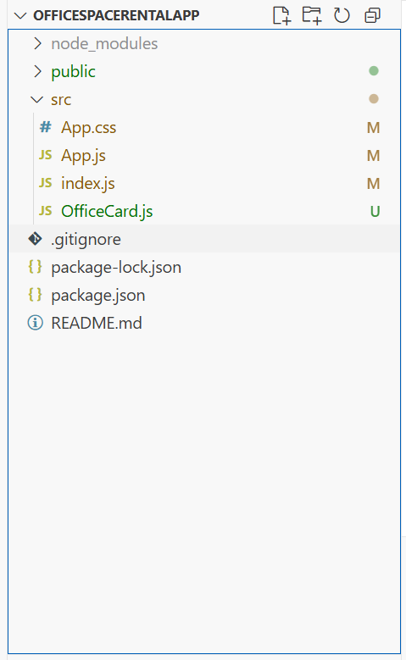
OfficeCard.js
import React from 'react';
import './App.css';

function OfficeCard({ item }) {
const rentColor = item.Rent <= 60000 ? 'textRed' : 'textGreen';

return (
<div className="card">
<img
src={process.env.PUBLIC_URL + '/' + item.Image}
width="25%"
height="25%"
alt="Office Space"
/>
<h2>Name: {item.Name}</h2>
<h3 className={rentColor}>Rent: Rs. {item.Rent}</h3>
<h3>Address: {item.Address}</h3>
</div>
);
}
export default OfficeCard;

index.js
import React from 'react';
import ReactDOM from 'react-dom/client';
import App from './App';

const root = ReactDOM.createRoot(document.getElementById('root'));
root.render(<App />);

App.js
import React from 'react';
import './App.css';
import OfficeCard from './OfficeCard';

function App() {
const offices = [
{ Name: "DBS", Rent: 50000, Address: "Chennai", Image: "office.jpg" },
{ Name: "WeWork", Rent: 65000, Address: "Bangalore", Image: "office.jpg" },
{ Name: "Innov8", Rent: 55000, Address: "Mumbai", Image: "office.jpg" },
];

return (
<div className="App">
<h1>Office Space , at Affordable Range</h1>
{offices.map((office, index) => (
<OfficeCard key={index} item={office} />
))}
</div>
);
}
export default App;

App.css
.App {
text-align: center;
margin: 40px;
font-family: Arial, sans-serif;
}

.textRed {
color: red;
}

.textGreen {
color: green;
}
.card {
margin: 30px auto;
}

